Calculus 2 Lecture 9.9: Approximation of Functions by Taylor Polynomials

A Taylor polynomial is a taylor series with a stopping endpoint, “taylor series goes on forever”

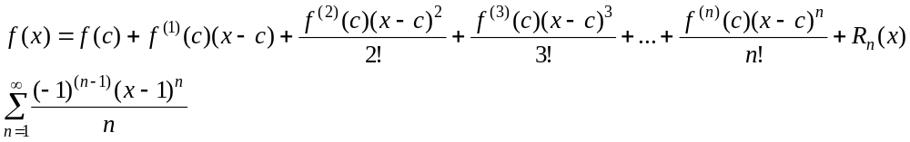
Nth degree taylor polynomial stops at the nth term plus the error

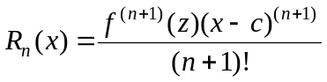z is a number between x and c to give biggest difference

Example
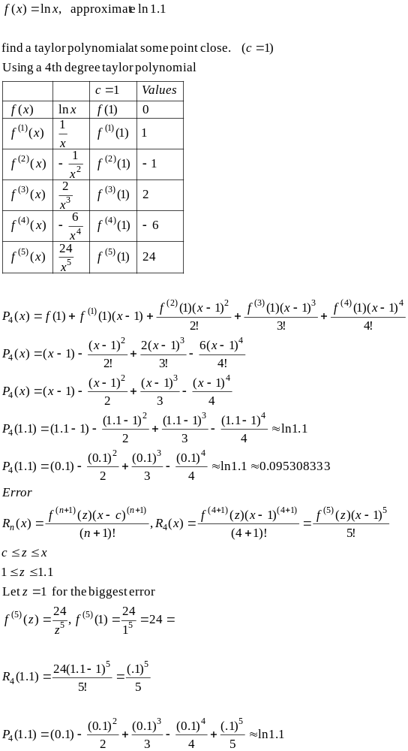
Example
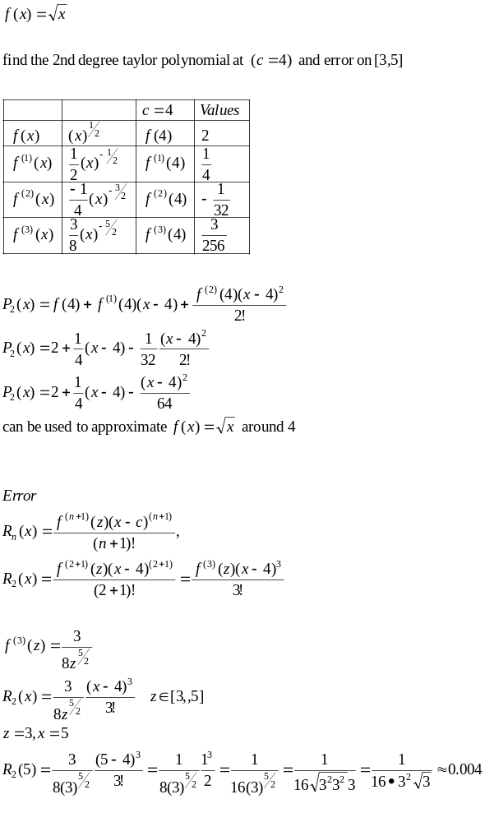

When does a function have a taylor series representation?
The remainder of a taylor polynomial is 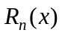

IDEA:
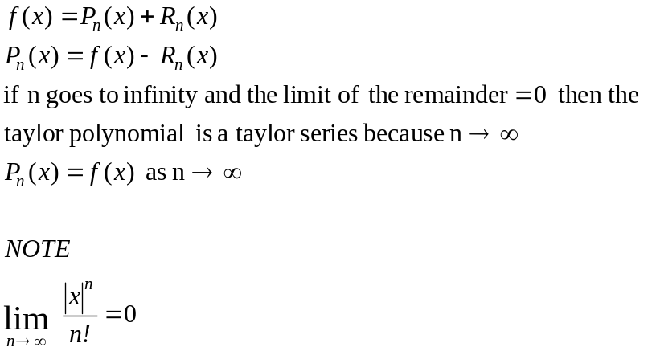

Example
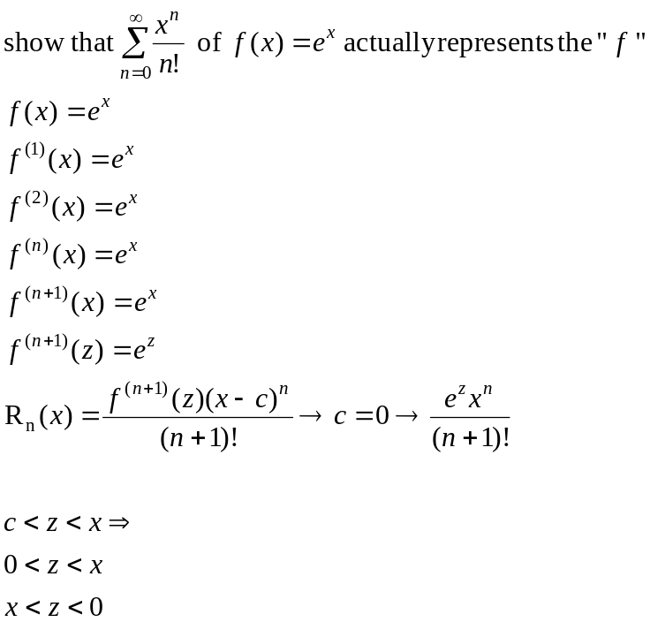
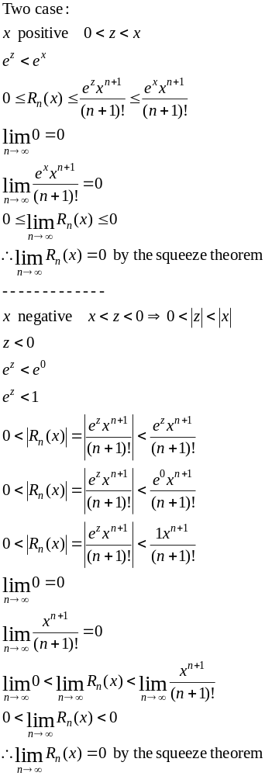

Example
